ASSIGNMENT 2
TASK 1

WAVE FORM SENTENCE: I AM REPAKA PRAKASH.

TIME DOMAIN PLOT ON AUDACITY

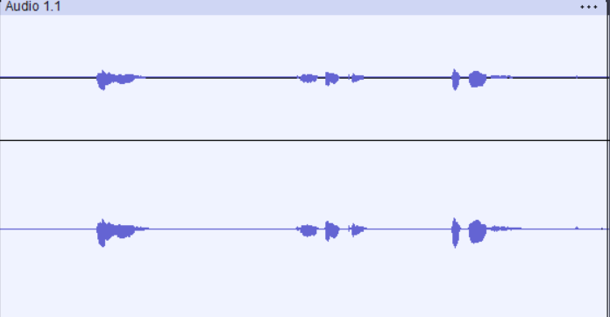

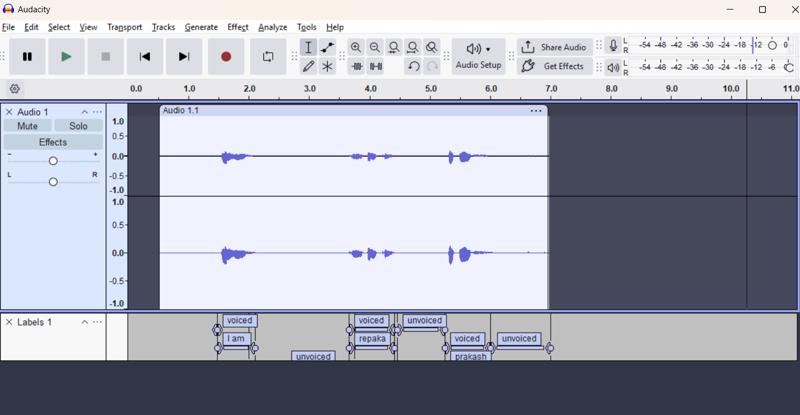VOICED & UNVOICED MARKING ON AUDACITY

WAVEFORM OF SELECTED REGION – “IAM”:

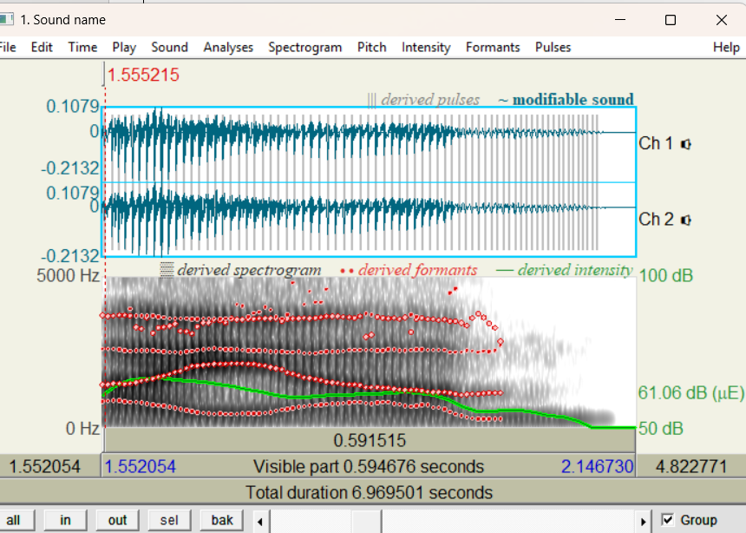
Energy
What it is: The "loudness" or amplitude of the signal.
Observation: The waveform is "tall," reaching high and low amplitude values.
ENERGY / INTENSITY of selected region : 61.658716598619904 dB (mean-energy intensity in SELECTION)mean of selected region )

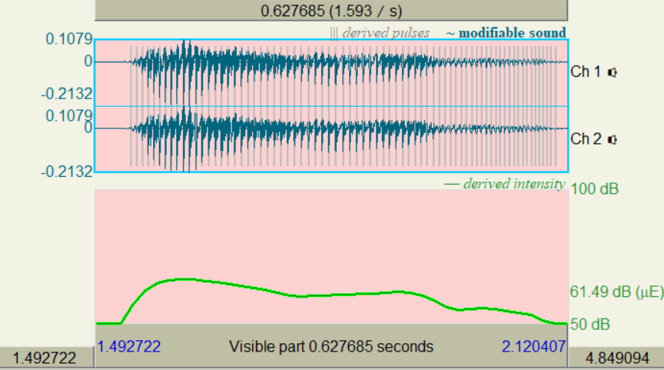

Voiced segments have High Energy because they are produced with significant power from the lungs and vocal folds.
COMMENT: INTENSITY IS RELATIVLY HIGH (79 DB) .This confirms the high energy nature of voiced sounds.

Autocorrelation

What it is: A measure of how well the signal matches a delayed version of itself. It's the best way to find periodicity.
Observation: The plot will show a series of clear, repeating peaks.
Autocorrelation is what Praat uses to find pitch.
PITCH: 120Hz
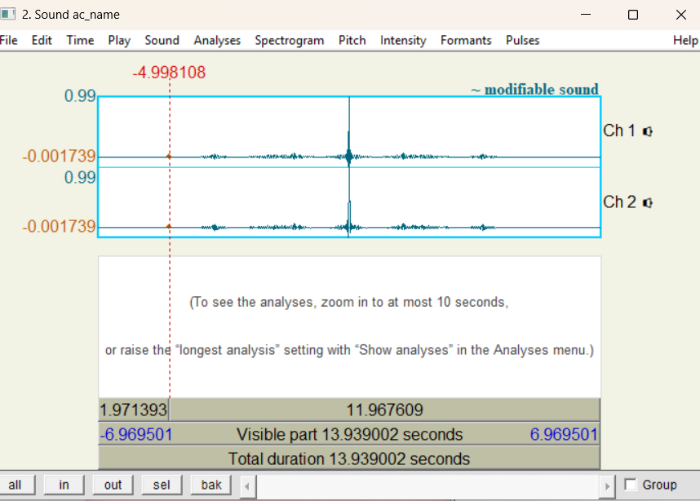

COMMENT: ABOVE 2ND FIGURE -You will see a plot with a strong, clear series of repeating peaks. This is the classic signature of a periodic, voiced sound.

ZERO-CROSSING RATE: ZCR
What it is: How many times the waveform crosses the '0' horizontal line.
Observation: You'll see the waveform looks like random static, crossing the zero line constantly and erratically.
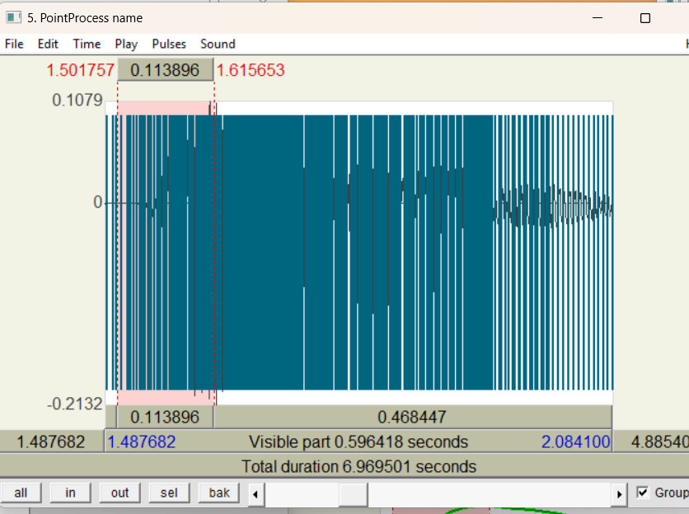

COMMENT: Voiced segments have a Low ZCR because their energy is concentrated in lower frequencies (the fundamental frequency and its harmonics).
What it is: How many times the waveform crosses the '0' horizontal line.
Observation: Zoom in. You'll see the waveform looks like random static, crossing the zero line constantly and erratically.

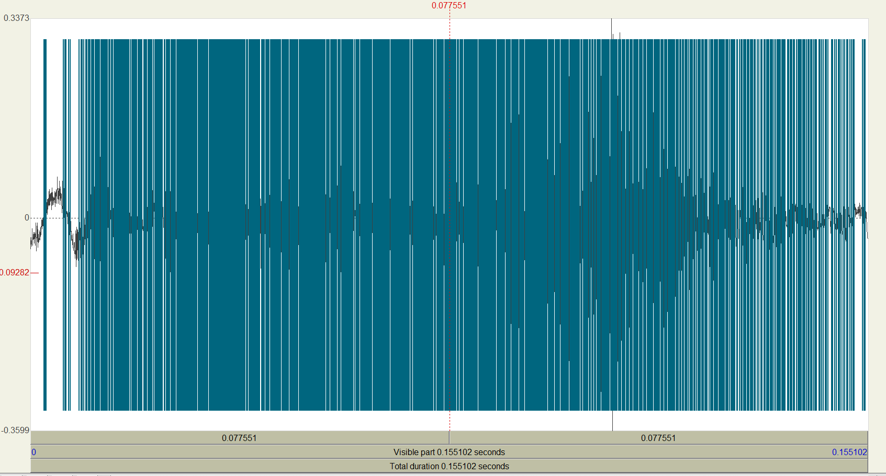

Definition: What Are Formants?
In simple terms, formants are the resonant frequencies of your vocal tract.
Think of your voice as a two-part system:
- The Source: Your vocal folds (vocal cords) vibrate, creating a "buzz" sound. This buzz has a base pitch ($F_0$) and many harmonics.
- The Filter: Your throat, mouth, and nasal cavity act as a "filter." By changing the shape of your mouth—using your tongue, jaw, and lips—you change the shape of this filter.
This filter amplifies (makes louder) certain frequencies from the "buzz" and dampens (makes quieter) others. The peaks of amplified frequency that come out in the final sound are the formants.
We label them $F_1$, $F_2$, $F_3$, and $F_4$, from lowest frequency to highest.
Spectral Details (F1, F2, F3)
The first two formants are the most important for identifying which vowel you are saying.
- $F_1$ (First Formant): This is related to vowel height (how open or closed your jaw is).
  - A low $F_1$ value means a closed or high vowel
  - A high $F_1$ value means an open or low vowel
- $F_2$ (Second Formant): This is related to vowel backness (how far forward or back your tongue is).
  - A high $F_2$ value means a front vowel
  - A low $F_2$ value means a back vowel
- $F_3$ (Third Formant): This is often related to "r-coloring" (rhoticity) and can help distinguish sounds like /l/ and /r/. It also adds to the overall timbre or quality of the voice.
- $F_4$ (Fourth Formant): This formant (and higher ones) are generally considered to be more related to your unique, individual voice quality and "ring" rather than identifying specific vowel sounds.

First, let's identify the main vowel sounds in your sentence: "I am Repaka Prakash". You will be looking for:
- /aɪ/ (the diphthong in "I")
- /æ/ (the vowel in "am")
- /ɑ/ (the vowel in "Repaka," and "Prakash,")
- /e/ (the vowel in "Repaka")
- /u/ (the vowel in "Prakash")
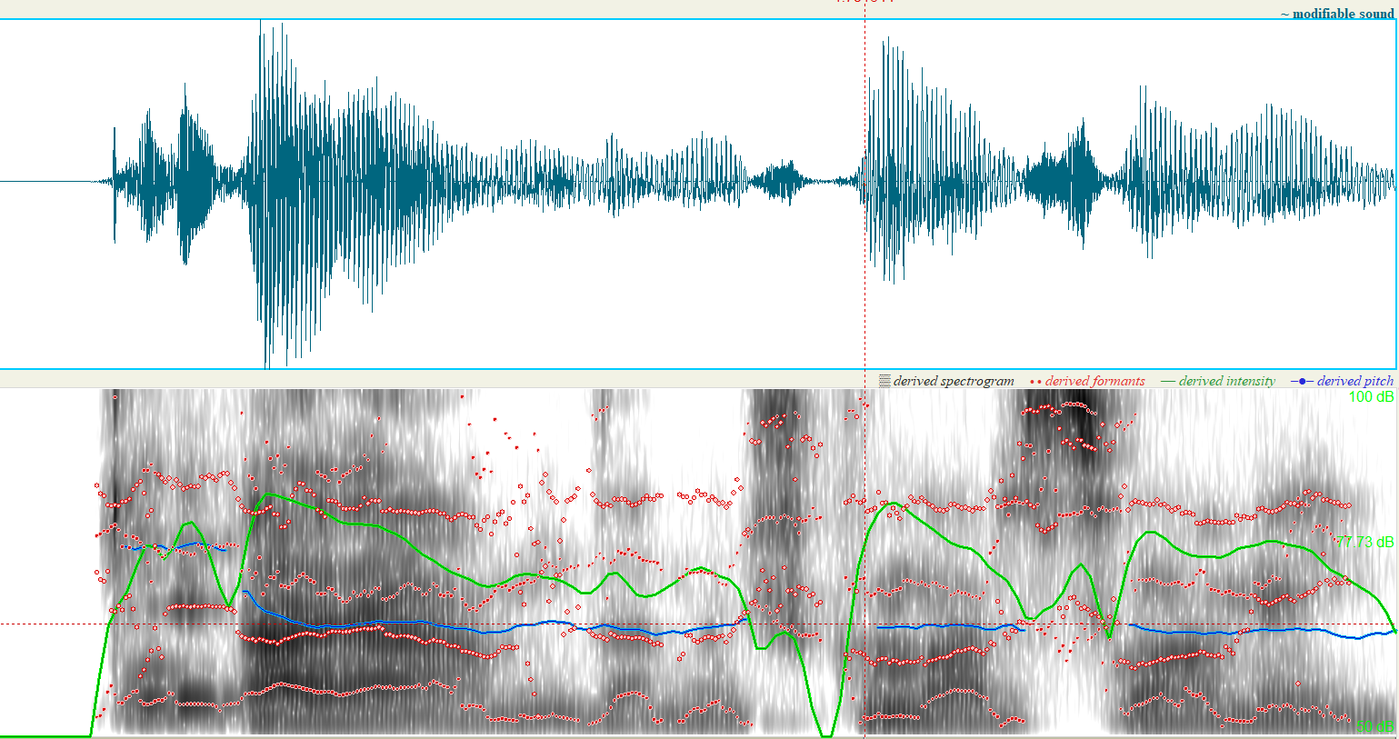

/aɪ/ (the diphthong in "I")
Time_s F1_Hz F2_Hz F3_Hz F4_Hz
1.554099 814.456631 1394.429394 2603.176391 3718.667216
1.560349 873.125516 1421.120099 2596.358593 3677.052957
1.566599 896.312282 1439.337801 2592.306481 3701.288673
1.572849 871.863068 1435.268318 2569.836482 3723.013572
1.579099 836.843143 1430.226275 2530.939746 3701.962366
1.585349 826.236011 1447.827966 2524.953896 3642.019941
1.591599 822.457964 1501.091412 2542.949039 3200.347970
1.597849 810.588388 1555.578753 2546.990569 3446.236852
1.604099 776.257865 1583.335914 2546.254254 3546.893707
1.610349 739.583505 1621.203371 2546.541218 3087.048337
1.616599 724.940045 1676.663963 2529.010737 3337.679820
1.622849 694.660623 1706.327063 2506.820690 3296.026164
1.629099 662.156519 1753.310406 2493.612726 3436.635211
1.635349 620.609431 1827.509477 2488.243526 3329.590367
1.641599 583.955994 1892.335717 2481.253805 3179.118922
1.647849 549.744875 1977.509306 2507.624964 3162.473697
1.654099 521.972703 2025.723475 2540.380777 3161.609280
1.660349 483.133049 2047.837425 2566.893910 3346.355341
1.666599 463.087699 2069.984428 2587.461481 3485.220237
1.672849 448.590231 2081.942020 2602.257186 3499.555403
1.679099 439.459614 2087.462913 2607.453008 3568.501238
1.685349 442.924956 2092.691025 2593.873107 3456.987306
1.691599 442.445626 2097.712448 2585.400586 3489.784017
/æ/ (the vowel in "am")
Time_s F1_Hz F2_Hz F3_Hz F4_Hz
1.680198 440.626007 2088.195132 2607.474110 3564.139107
1.686448 440.907712 2091.243781 2583.036842 3378.622686
1.692698 441.978733 2098.108590 2578.207086 3422.835705
1.698948 440.756218 2115.827618 2587.185592 3596.416010
1.705198 440.509470 2118.734575 2575.280690 3561.788489
1.711448 446.456875 2106.717966 2548.546025 3574.988946
1.717698 449.877276 2098.148928 2537.299634 3584.240241
1.723948 453.675601 2086.193067 2542.432231 3597.195369
1.730198 465.330561 2047.340361 2543.767448 3605.283838
1.736448 482.494925 2012.897703 2537.982653 3601.993717
1.742698 502.153308 1972.702595 2509.793690 3606.906858
1.748948 553.051202 1939.756223 2503.408884 3507.708048
1.755198 589.229677 1850.764891 2494.302489 3553.488119
1.761448 605.304660 1790.384222 2494.658607 3593.295609
1.767698 649.054766 1744.677022 2502.775970 3610.710658
1.773948 682.217488 1674.231902 2470.945554 3610.095909
1.780198 698.790426 1639.883147 2448.082357 3618.771626
1.786448 720.944599 1604.103136 2448.088387 3616.233047
1.792698 743.505253 1558.858600 2467.527131 3639.849794
1.798948 756.579101 1533.789859 2497.442438 3656.549128
1.805198 767.265724 1497.283934 2508.658541 3683.735785
1.811448 772.482817 1462.322013 2501.088398 3680.801985
1.817698 786.564544 1444.145693 2522.980137 3681.117989
1.823948 798.558614 1418.471187 2538.486336 3650.257498
1.830198 825.287075 1412.505143 2566.569996 3625.142257
1.836448 844.135986 1404.227950 2560.619600 3635.955185
1.842698 796.690620 1364.000380 2556.005277 3723.350306
1.848948 777.753426 1309.557103 2556.165658 2886.277830
1.855198 795.700535 1313.601731 2550.181662 3234.513333
1.861448 809.675134 1311.067159 2548.726123 3633.793287
1.867698 845.837541 1303.683245 2555.064925 3609.676789
1.873948 804.460857 1269.604996 2584.790095 3221.056858
1.880198 769.017527 1257.400434 2573.303182 3627.817443
1.886448 732.737974 1238.918583 2545.794869 3576.635461
1.892698 696.396967 1226.113348 2543.855734 3264.565728
1.898948 694.825212 1220.075738 2564.741451 3317.177337
1.905198 703.834189 1218.113915 2576.591841 3644.342104
1.911448 739.717963 1188.937843 2569.033806 3604.423387
1.917698 704.206468 1168.492682 2551.978628 3590.513653
1.923948 647.389868 1156.014077 2562.707317 3558.083885
1.930198 636.294220 1156.988948 2567.083635 3561.128433
1.936448 567.631215 1143.776133 2531.278692 3558.165119
1.942698 462.356931 1121.282783 2480.761059 3508.465244
1.948948 408.011073 1083.085350 2486.615879 3520.934563
1.955198 350.294532 1067.022475 2514.935227 3394.176716
1.961448 311.807736 1087.782438 2552.627289 3481.468907
1.967698 278.510779 1103.941963 2495.935066 3716.595684
1.973948 275.164868 1096.808328 2508.140366 3744.269500
1.980198 276.946122 1129.457456 2527.819257 3569.688475
1.986448 272.977889 1133.654849 2497.150774 3328.924982
1.992698 278.193722 1147.880537 2601.913896 3234.441412
1.998948 279.906774 1121.287098 2679.707102 2697.767025
2.005198 283.199765 1108.230153 2522.632958 3167.275658
2.011448 281.748966 1077.721514 2537.513365 3527.718625
2.017698 278.800545 919.127803 2486.348480 3347.295149
2.023948 278.201907 993.066599 2296.840977 2946.862934
2.030198 267.106434 1069.093066 2272.059170 2904.196291
2.036448 261.918919 1021.130310 2389.159026 2834.620379
2.042698 273.616067 958.871506 2444.037463 2752.758227
2.048948 276.385171 832.232581 2341.939385 3033.429202
2.055198 282.562754 2341.138680 2520.087884 3739.635572
2.061448 225.344733 1784.138008 2619.009808 3948.230396
2.067698 194.458987 1121.147132 2635.067891 4166.179084
2.073948 188.526887 1491.286429 2611.095030 4329.442305
2.080198 194.456346 1979.553399 2561.208726 4592.482917
2.086448 197.395085 1973.707201 2649.111868 4072.683991
2.092698 193.306442 2140.341610 2862.463672 4177.193794
2.098948 189.794560 1849.949985 2894.378808 4297.682683
2.105198 197.129765 1829.240602 3007.350315 4331.259902
2.111448 204.193631 1814.348616 3093.772711 4395.614240
2.117698 204.897365 1741.488626 3056.633906 4341.903574

/e/ (the vowel in "Repaka")

Time_s F1_Hz F2_Hz F3_Hz F4_Hz
3.762258 627.832100 1788.322050 2488.828173 2910.480164
3.768508 596.248641 1793.611774 2453.862965 2984.023829
3.774758 616.937082 1859.702537 2475.439962 3108.351416
3.781008 634.485372 1886.148096 2519.016520 3121.525969
3.787258 620.792966 1888.665574 2523.932922 3086.244825
3.793508 603.824286 1898.079152 2536.046230 2956.321915
3.799758 582.692766 1887.709390 2487.834954 2993.194800
3.806008 564.134291 1902.022791 2475.856950 3272.399793
3.812258 567.892618 1920.132740 2432.472141 3056.409030
3.818508 561.706642 1904.820383 2400.224411 3139.085744
3.824758 557.425190 1880.269024 2427.733523 3349.691430
3.831008 550.747744 1828.669878 2503.867533 3315.994036
3.837258 535.755802 1848.891065 2550.150822 3239.650056
3.843508 538.870932 1910.418063 2551.213478 3342.912609
3.849758 533.656665 1909.299203 2484.952299 3124.955985
3.856008 527.783660 1824.590804 2471.750363 3369.262129
3.862258 526.275127 1772.017606 2416.102535 3460.436072
3.868508 514.595607 1686.206830 2331.605479 3369.992492
3.874758 490.015477 1594.294842 2268.538396 3608.910680
3.881008 465.213203 1482.769620 2242.966174 3631.113442
3.887258 372.012698 1220.641703 2271.645826 3569.758401
3.893508 435.581578 1709.349845 2415.123731 3594.214513
3.899758 356.502293 1735.861151 2481.128039 3637.062554
3.906008 359.394112 1547.106977 2457.278082 3632.467137
3.912258 305.499488 1538.485342 2510.518583 3585.678774
3.918508 271.418374 1507.187867 2572.784684 3544.414342
3.924758 260.450166 1499.142946 2414.939664 3172.030717
3.931008 219.970582 1673.262353 2350.186960 3505.359011
3.937258 1391.159238 2541.587277 3554.459025 --undefined--
3.943508 1086.930916 2522.667970 3531.480736 4054.861015
/a/ (the vowel in "Repaka")

Time_s F1_Hz F2_Hz F3_Hz F4_Hz
4.016939 676.148744 1218.205946 2539.897636 3730.373088
4.023189 708.350541 1260.956899 2479.879673 3848.828749
4.029439 753.313409 1296.580575 2484.539703 3892.249818
4.035689 792.196871 1356.352954 2512.816621 3838.921063
4.041939 800.542085 1321.404511 2490.913620 3712.605951
4.048189 795.571011 1324.965068 2498.085487 3715.411010
4.054439 784.836024 1302.033658 2512.765708 3656.542952
4.060689 807.727377 1285.097857 2519.583783 3729.420577
4.066939 795.157025 1288.625802 2503.765248 3722.612661
4.073189 778.640605 1278.904850 2507.473676 3692.081312
4.079439 767.698673 1270.444132 2498.916006 3651.267970
4.085689 771.646458 1285.273422 2511.435230 3687.796457
4.091939 733.767384 1329.243844 2494.888620 3699.577582
4.098189 700.330443 1348.979187 2494.139488 3683.769598
4.104439 704.446702 1329.994715 2513.370308 3770.266084
4.110689 624.063902 1340.373590 2504.407070 3849.695589
4.116939 595.075694 1328.848919 2516.801391 3733.763331
4.123189 565.555880 1349.532887 2545.137838 3740.728849
4.129439 539.147662 1337.878672 2506.297400 3807.197352
4.135689 436.126131 1298.051775 2518.506671 3832.013590
4.141939 539.058800 1276.273367 2485.566143 3831.632564
4.148189 598.306187 1324.436653 2470.048925 3595.141790
4.154439 577.259686 1337.751187 2501.928650 3489.116413
4.160689 515.272054 1345.999462 2604.758279 3857.733602
4.166939 547.043794 1365.851670 2663.313338 4114.130619
4.173189 1245.915320 2761.178546 4159.437694 --undefined--
4.179439 427.922861 1291.044690 2775.077277 4043.273790
1st /a/ (the vowel in "Prakash")

Time_s F1_Hz F2_Hz F3_Hz F4_Hz
5.360213 660.504562 1620.152935 2221.663298 3607.006565
5.366463 660.821206 1694.833160 2223.179371 3615.318544
5.372713 659.161314 1718.645168 2206.667752 3631.728800
5.378963 650.286165 1726.756743 2179.929125 3638.174616

2nd/a/ (the vowel in "Prakash")

Time_s F1_Hz F2_Hz F3_Hz F4_Hz
5.597713 745.252989 1252.132668 2399.999149 3450.453122
5.603963 766.203225 1245.875056 2382.706225 3459.052607
5.610213 762.346631 1248.906126 2358.171543 3448.492315
5.616463 753.477403 1258.539549 2349.842295 3458.822845
5.622713 760.708413 1267.560777 2308.280996 3467.043424
5.628963 749.478534 1287.619333 2246.180931 3471.296603
5.635213 730.582536 1310.605871 2241.873808 3482.510768
5.641463 743.546732 1335.633370 2259.299256 3508.002505
5.647713 754.004950 1371.015858 2289.536729 3517.804134
5.653963 785.199249 1440.623883 2324.313135 3518.896087
5.660213 808.379037 1484.272454 2342.136908 3509.590477
5.666463 736.173473 1519.429746 2393.205293 3582.401171
5.672713 664.440745 1521.827207 2378.817320 3607.474694
5.678963 625.871700 1579.538426 2388.003916 3612.609538
5.685213 1471.240180 2463.271784 3657.077590 5193.869829
5.691463 1390.945718 2642.190060 3750.728160 4901.896237
5.697713 1326.073258 2565.866375 3670.081147 4736.636825

